***ZOMATO DATA ANALYSIS***

**By Muhammad Sahanwaj**

**Problem Statement**

You are hired as a consultant data analyst by zomato where the team is looking for expansion and opening more restaurants. Your task is to develop strategies/suggestions about opening newer restaurants.

**Objective Questions**

***1.The data consists of some inconsistent and missing values so ensure that the data used for further analysis is cleaned.***

**Method used for missing values & cleaning the data:**

**Conditional Formatting: -** The data provided have missing values, so I have selected Raw data table and go to home tab then apply conditional formatting, select highlights cells rule, select more rules, format only cells with, select Blanks and custom with colour, then found missing values in column name Cuisines.

**Find & Replace data:-** The provided data have missing values so, I have applied filter in Raw data table then select column name Cuisines and select blank after that to fill the blank cells, I have used average of values then I replaced blank cells with “North Indian”.

***2.Using the LOOKUP functions, fill up the countries in the original data using the country code.***

**Function used for extracting country from the country code:**

**Vlookup Function -** As the common value in raw data sheet and country description sheet is country code. Therefore, I have used Vlookup (as it lookups the value in a vertical column).

Formula used: =VLOOKUP (C2,'country description’! $A$2: $B$16,2,0)

C2 - It is the country code selected for searching.

country description’! $A$2: $B$16 - This is the range where

the code will be searched.

2 - This is the column number where the country will be searched.

0 - This is used to denote the match type. And zero means exact match.

***3.Create a table to represent the number of restaurants opened in each country.***

**Function used to here to count the restaurants opened in each country:**

**Pivot Table** - As the question asks to create a table and show no. of restaurants in each country. For this I have to count the number of restaurants therefore I have used a Pivot table in which I take Country in Rows and Restaurant Name in values and sort by Count.

THIS CHART IS ON PIVOTS SHEET CELL NO(A1)

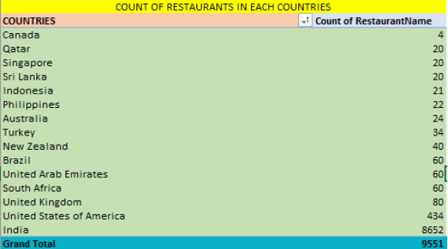

***4.Also the management wants to look at the number of restaurants opened each year, so provide them with something here.***

**Function used to here to count the restaurants opened in each Year:**

Pivot Table - As the question asks to create a table and show no. of restaurants in each country. For this I have to count the number of restaurants opened in each year therefore I have used a Pivot table in which I take Year in Rows and Restaurant Name in values and sort by Count.

THIS CHART IS ON PIVOTS SHEET CELL(D1)

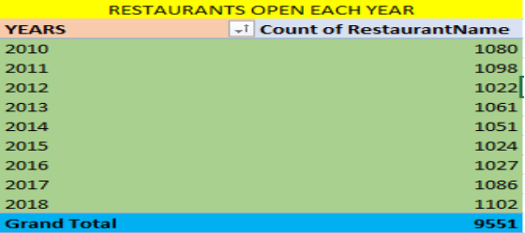

***5.What is the total number of restaurants in India in the price range of 4?***

**Function used here to count total restaurants in India in price Range of 4:**

Pivot Table - As the question asks to show no. of restaurants in India in price range of 4. Therefore, I have used Pivot table in which I take Country and Price Range in Filter and Restaurant Name in values and sort by Count.

THIS CHART IS ON PIVOTS SHEET CELL(A94)

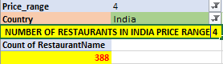

***6. According to the data What is the average number of voters for the restaurants in each country?***

**Function used here to average the number of voters for the restaurants in each county.**

Pivot Table - As the question asks the average number of voters for the restaurants in each country. Therefore, I have used the Pivot table in which I take Country in Row and Votes in values and sort by Average.

THIS CHART IS ON PIVOTS SHEET CELL(N20)

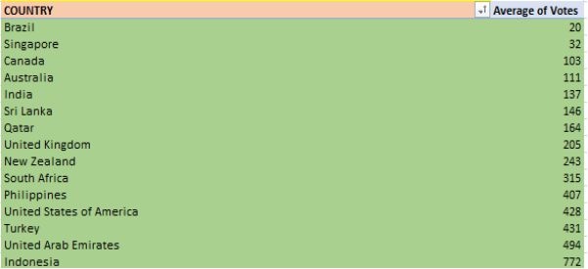

**Subjective Questions**

***1. Suggest few countries where the team can open newer restaurants with lesser competition. Which visualisation / Technique will you use here to justify the suggestions?***

**Method used:** I have used the dashboard and selected the countries on the slicer who have lesser average ratings and the number of restaurants open there are less compared to other countries.

I have used the Pivot table, in which I take countries in row and rating in value sort by average.

**Analysis: Upon** observation, I recommend focusing on countries with less competition and lower average ratings. The rationale behind selecting average ratings is that it indicates potential dissatisfaction among customers with existing restaurants. This presents an opportunity for Zomato to conduct market surveys, analyse the reasons for dissatisfaction, and address them when opening new restaurants. By addressing customer concerns, Zomato can improve satisfaction levels and gain a competitive edge in these markets.

**Countries Suggested for opening new restaurant**:

CANADA, SINGAPORE, SRI LANKA.

THIS CHART IS ON PIVOTS SHEET CELL(D43) THIS CHART IS ON PIVOTS SHEET CELL(A1)

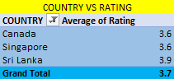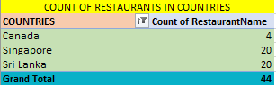

**Visualisation method used**: - Cluster column chart shown below.

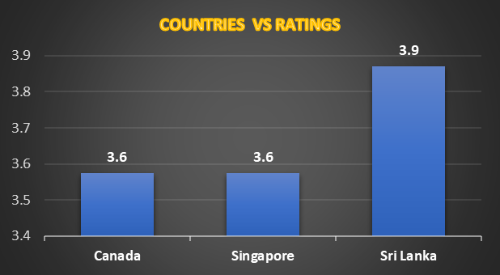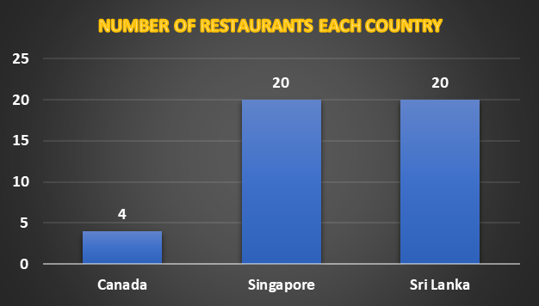

***2. Come up with the names of States and cities in the suggested countries suitable for opening restaurants?***

**Method used:** I have used a dashboard and applied filters on the Country Slicer and selected the suggested countries to find the cities with lesser average ratings.

I have used the Pivot table, in which I take cities in row and, rating in value and sort by average.

**Country - City selected:**

**CANADA** – Consort, Yorkton, Chatham-Kent

**SINGAPORE** - Singapore

**SRI LANKA** – Colombo

THIS CHART IS ON PIVOTS SHEET CELL(I62)

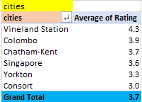

**Visualisation method used**: - Cluster Column chart shown below.

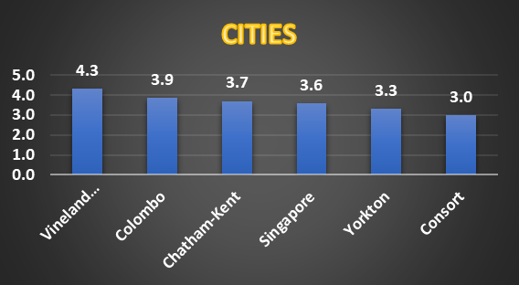

***3. According to the countries you suggested, what is the current quality regarding ratings for restaurants that are opened there?***

**Method used: -** I have used the Pivot table, in which I take countries in row, rating in value and sort by average. And I have used the dashboard and applied filter on the country slicer based on suggested countries.

**Country with Average Rating: -**

THIS CHART IS ON PIVOTS SHEET CELL(D43)

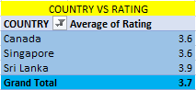

**Visualisation method used**: - Cluster Column chart shown below.



***4. Also what is the current expenditure on the food in the suggested countries, so that we can keep our financial expenditure in control?***

**Method used: -** I have used the Pivot table, in which I take countries in row, average cost for two in value and sort by average. And I have used the dashboard and applied filter on the country slicer based on suggested countries.

**Current Expenditure On Food:**

THIS CHART IS ON PIVOTS SHEET CELL(K1)

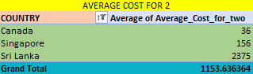

**Visualisation method used**: - Bar chart shown below

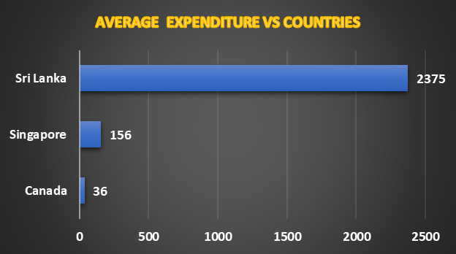

***5. Come up with the names of restaurants from the recommended states that are our biggest competitors and also those which are rated in the lower brackets, i.e. 1-2 or 2-3?***

**Method used:** I have made a pivot table in the pivots sheet where I have put the Restaurants on row and ratings in values and applied a filter on a country slicer and rating slicer with the suggested countries on the dashboard to find the highest and the lowest rated restaurants.

**Restaurants who are our biggest competitors** are marked in yellow colour whereas restaurants who have lowest rating are marked in red as we can see on the below charts

THIS CHART IS ON PIVOTS SHEET CELL(A209)

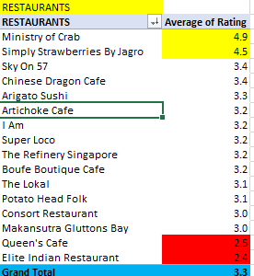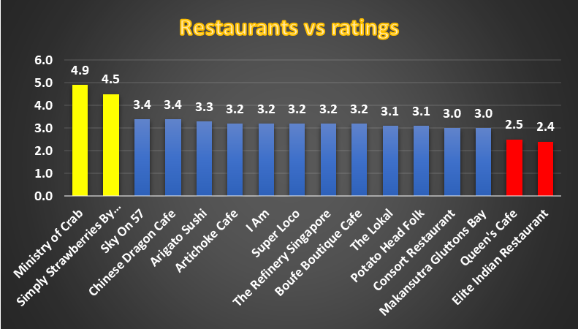

***6. Which cuisines should we focus on in the newer restaurants to get better feedback? Does the choice of cuisines affect the restaurant ratings?***

**Method used:** I have made a pivot table in the pivots sheet where I have put the Cuisine on row and ratings in values and applied a filter on a country slicer and highest rating on the rating slicer with the suggested countries on the dashboard to find the highest rated Cuisine.

**CUISINES TO FOCUS -**

THIS CHART IS ON PIVOTS SHEET CELL(G209)

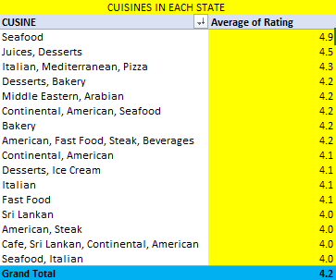

**The choice of cuisines -** affect the ratings of every country as their own local food choices and preferences. For example, if you are selling food in another country it would not sell as much as it would sell in Canada.

**Basis for suggestion** - The basis I have taken the highest ratings. Cuisines which are local to that country are high in rating and other than this other food preference which are famous in all countries are like seafood, Italian.

**Decision** - As by observing the pivot table, I analyse that some cuisines like seafood and Italian are having very high ratings due to its popularity in that country. The decision is that cuisine affects the rating based on the observation. These analyses provide a starting point for understanding trends and patterns in the data, allowing to make informed decisions and improvements in the restaurant business based on customer feedback and preferences.

**7. According to our current data, should we go for online delivery and table booking? Does that affect the customer’s rating?**

**Method used :-** I have used a Two Pivot table, For table booking I take table booking in row and count of restaurants in value.  
For online delivery I take online delivery in row and count of restaurants in value.

And I have used the dashboard and applied filter on the country slicer based on suggested countries.

THIS CHART IS ON PIVOTS SHEET CELL(D21) THIS CHART IS ON PIVOTS SHEET CELL(I21)

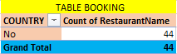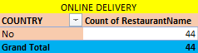

**Visualisation method used: - Pie chart shown below**

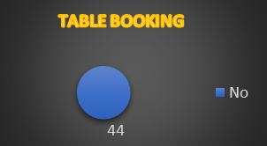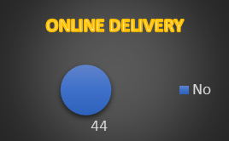

**Decision -**We should go for table booking and online delivery. As none of the restaurants are providing this facility. This can be an edge over our competitors. But for doing this we can go for a survey to know if people in that country are willing to go for online delivery and table booking or not.

**Cost vs. Services**: Explore if there is a relationship between the cost for two and the availability of table booking or delivery services. Analyse whether customers are willing to pay more for the convenience of these services.

**Geographical Trends**: Consider exploring if the prevalence of table booking and delivery services varies by country or region.

***8. Should the team keep the rate of cuisines higher? Will that affect the feedback? According to our data are the rate of cuisines and ratings, correlated?***

**Method used:** I have used CORREL Function to find the correlation between rate of cuisines and ratings.

**Formula Used: - =CORREL (E3:E1828, F3:F1828)**

**Decision:** We can keep the rate of cuisines higher, as the correlation is very negligible between rating and rate of cuisines.

**Visualisation method used**: - Scatter chart shown below

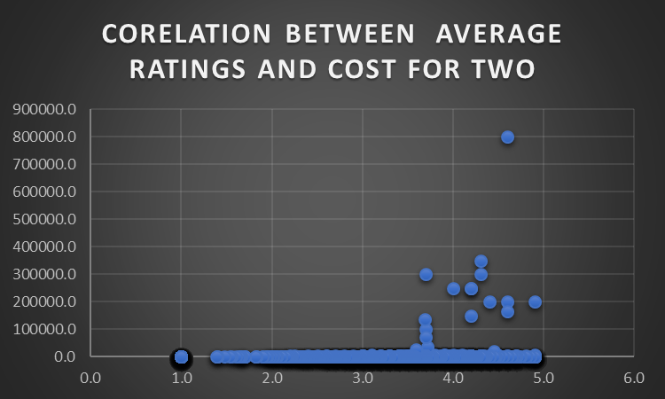

**Location:** Excel File - sheet named - Correlation

***9. What is the distribution of the number of restaurants of different price ranges in all the countries?***

**Method used**: I have used a Pivot table, in which I took the price range in row, Restaurant name in value and sort by count*.*

THIS CHART IS ON PIVOTS SHEET CELL(F70)

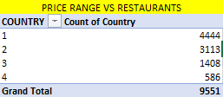

**Visualisation method used: -** Column chart shown below

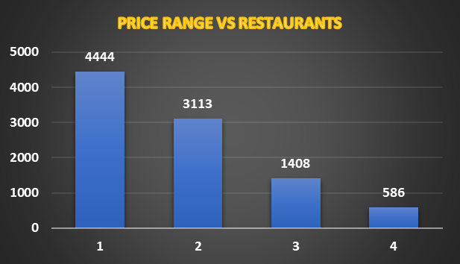

**Cell Reference in Dashboard: -**



I did cell reference for this in excel file location pivots sheets cell (=PIVOTS! C18)



I did cell reference for this in excel file location pivots sheets Cell (=PIVOTS! N1891)



I did cell reference for this in excel file location pivots sheets Cell (=PIVOTS! C70)



I did cell reference for this in excel file location pivots sheets Cell (=PIVOTS! M198)



I did cell reference for this in excel file location pivots sheets Cell (=PIVOTS! K42)